Classification of data
(structured, semi-structured, unstructured):
- Structured data –
- Structured data is generally tabular data represented by columns and rows in a database.
- Databases that hold tables in this form are called relational databases.
- The mathematical term “relation” specifies a formed set of data held as a table.
- In structured data, all row in a table has the same set of columns.
- SQL (Structured Query Language) programming language used for structured data.
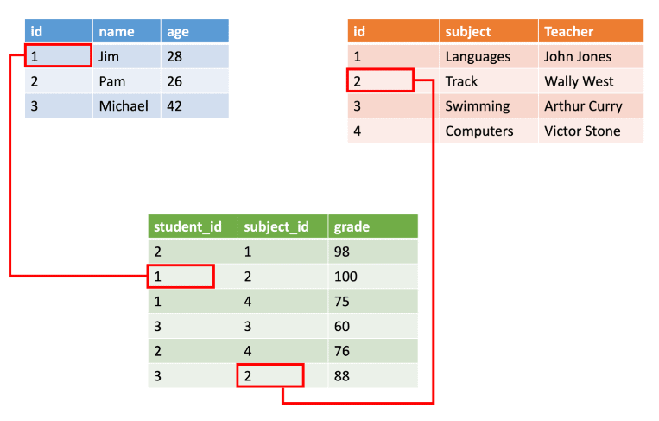
Pros and Cons of Structured Data
Pros | Cons
- Requires less processing in comparison to unstructured data and is easier to manage. | - Limited usability because of its pre-defined structure/format
- Machine algorithms can easily crawl and use structured data which simplifies querying | - Structured data is stored in data warehouses which are built for space saving but are difficult to change and not very scalable/flexible.
- As an older format of data, there are several tools available for structured data that simplify usage, management, and analysis

Use cases for Structured data

- Examples of structured data include names, dates, addresses, credit card numbers, stock information, geolocation, and more.
- Structured data is highly organized and easily understood by machine language. Those working within relational databases can input, search, and manipulate structured data relatively quickly using a relational database management system (RDBMS).
Examples of relational databases:
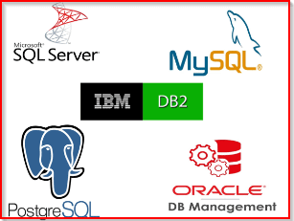

- Semi-structured data –
- Semi-structured data is information that doesn’t consist of Structured data (relational database) but still has some structure to it.
- Semi-structured data consists of documents held in JavaScript Object Notation (JSON) format. It also includes key-value stores and graph databases. f sem. XML files that are defined by an XML schema are also semi structured data.
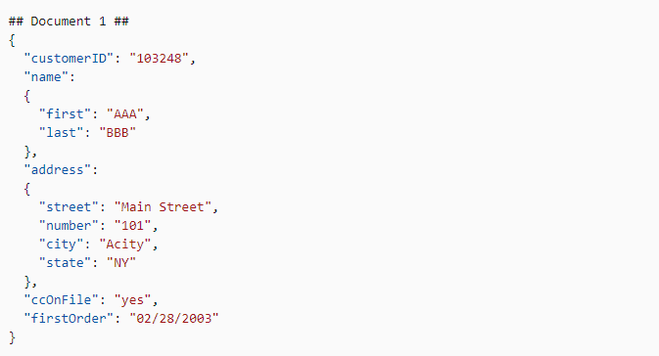

Use cases for Semi-Structured data:

The use of semi-structured data enables us to integrate data from various sources or exchange data between different systems. Applications and systems need to evolve with time, but if we work purely with structured data, this is not possible. Let’s consider web forms. You may want to modify forms and capture different data for different users. If you are using a traditional relational database, the database schema needs to be changed each time a new field is needed, and fields can not be left empty. Semi-structured data can allow you to capture any data in any structure without making changes to the database schema or coding. Adding or removing data does not impact functionality or dependencies.
- Unstructured Data –
- Unstructured data is information that either is not organized in a pre-defined manner or does not have a pre-defined data model.
- Unstructured information is a set of text-heavy but may contain data such as numbers, dates, and facts as well.
- Videos, audio, and binary data files might not have a specific structure. They’re assigned to unstructured data.
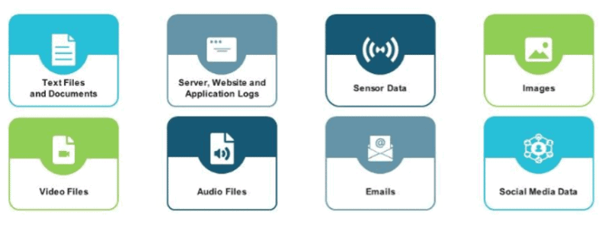

This type of data doesn’t have an information model and isn’t organized in any specific format. Some samples of unstructured data are e-mails, displays, images, text documents, PDF files, and videos. Approximately 90% of the digital data generated these days is non-structured data which is either semi-, quasi-, or unstructured data.

Pros and Cons of Unstructured Data
Pros | Cons
A variety of native formats facilitates a greater number of use cases and applications | The greater number of formats makes it equally challenging to analyze and leverage unstructured data.
As there is no need to predefine data, unstructured data is collected quickly and easily. | The large volume and undefined formats make data management a challenge and specialized tools a necessity.
Unstructured data is stored in on-premises or cloud data lakes which are highly scalable.
Although challenging, the greater volume of unstructured data provides better insights and more opportunities to turn your data into a competitive advantage.
Use cases for unstructured data
Here are a few examples where unstructured data is being used in analytics today.
- Classifying image and sound. Using deep learning, a system can be trained to recognize images and sounds. The systems learn from labeled examples in order to accurately classify new images or sounds.
- As input to predictive models. Text analytics — using natural language processing (NLP) or machine learning — is being used to structure unstructured text.
- Chatbots in customer experience. Chatbots have been in the market for a number of years, but the newer ones have a better understanding of language and are more interactive.
Examples of non-relational databases:
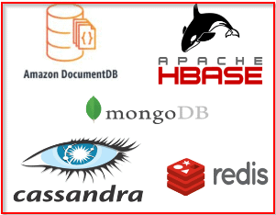

Differences between Structured, Semi-structured, and Unstructured data:
Properties | Structured data | Semi-structured data | Unstructured data
Technology | It is based on Relational database table | It is based on XML/RDF(Resource Description Framework). | It is based on character and binary data
Transaction management | Matured transaction and various concurrency techniques | Transaction is adapted from DBMS not matured | No transaction management and no concurrency
Version management | Versioning over tuples,row,tables | Versioning over tuples or graph is possible | Versioned as a whole
Flexibility | It is schema dependent and less flexible | It is more flexible than structured data but less flexible than unstructured data | It is more flexible and there is absence of schema
Scalability | It is very difficult to scale DB schema | It’s scaling is simpler than structured data | It is more scalable.
Robustness | Very robust | New technology, not very spread | —
Query performance | Structured query allow complex joining | Queries over anonymous nodes are possible | Only textual queries are possible

